**Project Design Phase-I**

**Solution Architecture**

|  |  |
| --- | --- |
| Date | 06 May 2023 |
| Team ID | NM2023TMID14694 |
| Project Name | CANCER VISION : Advanced Breast Cancer Prediction with Deep Learning |

**Solution Architecture:**

Solution architecture is a complex process – with many sub-processes – that bridges the gap between business problems and technology solutions. Its goals are to:

* Find the best tech solution to solve existing business problems.
* Describe the structure, characteristics, behaviour, and other aspects of the software to project stakeholders.
* Define features, development phases, and solution requirements.
* Provide specifications according to which the solution is defined, managed, and delivered.

**Solution Architecture Diagram:**

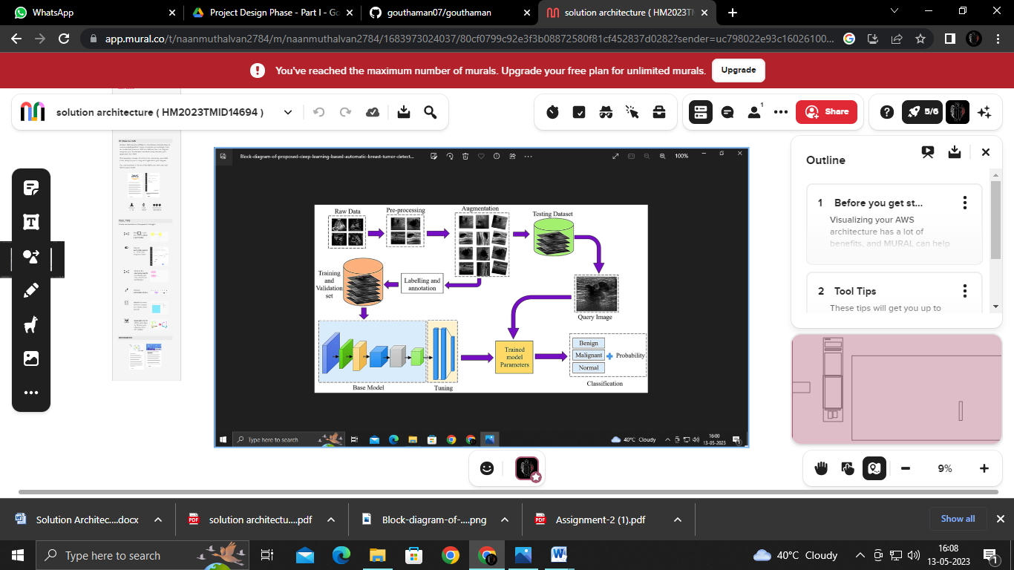

*Figure 1: Architecture and data flow of the voice patient diary sample application*

**Reference:** [**https://app.mural.co/t/naanmuthalvan2784/m/naanmuthalvan2784/1683973024037/80cf0799c92e3f3b08872580f81cf452837d0282?sender=uc798022e93c1602610037643**](https://app.mural.co/t/naanmuthalvan2784/m/naanmuthalvan2784/1683973024037/80cf0799c92e3f3b08872580f81cf452837d0282?sender=uc798022e93c1602610037643)